Predicting Oxygen Consumption Via Deep Learning

  - Redback Operations

  - Protype Team

  - Andrew Mayes

Abstract

The ability to predict oxygen consumption (VO₂) is typically an expensive process requiring specialised equipment and specialised know-how. With the rise in internet of things (IoT), combined with deep learning methods one starts to question if these expensive processes can be replaced with simple yet reliable ones. The following report aims to demonstrate that simple measures of heart rate, power output and several others can predict VO₂ accurately without the need of sophisticated equipment or highly sanitised conditions. The results indicated that predicted oxygen consumption values are strongly correlated (R² = 0.89) with actual oxygen consumption values. Thus, one can conclude that the reported model is effective in prediction VO₂ values without the need for expensive instruments or highly sanitised environments.

Predicting Oxygen Consumption Via Deep Learning

In the age of digitalisation, individuals varying from average joe to Olympic athletes are seeking ways to capture personalised information to inform decision-making. Under the umbrella of sport, fitness, and health, this is no different. In fact, the rise in internet of things (IoT) has seen an explosion within last decade with companies such as Fitbit, Myfitnesspal, or Google Nest. Smart devices provide an opportunity for companies gain valuable data, which when used correctly allows companies to gain insights. These insights can allow companies to offer more personalised features to clientele allowing for improved customer experience. Especially as individuals are becoming more and more health concerned as lifestyles become increasingly sedentary.

Oxygen consumption – VO₂

Why is VO₂ important?
VO₂ since being first proposed has been associated with a wide range of health, exercise and sporting components including but not limited to bodyfat percentage, power output, and even quality of life.

What is VO₂ exactly?
VO₂, put simply, is the volume (V) of oxygen (O₂) being consumed by an individual during a defined period of activity. Typically, activity refers to physical activity or rather physical exercise as one could technically include any activity that includes oxygen. VO₂ is typically represented in either relative terms as millilitres of oxygen consumed per kilogram of bodyweight per minute (ml/kg/min) or in absolute terms as millilitres of oxygen consumed per minute (ml/min) with bodyweight being the difference between the two methods.

How to measure VO₂?
There are several methods widely used to measure VO₂, which vary in terms of accuracy. The most accurate method requires using a face mask with sensors to measure the ratio of oxygen to carbon dioxide for both inhalation and exhalation. Depending on the specific equipment used these devices vary in portability and applicability (Figure 1).

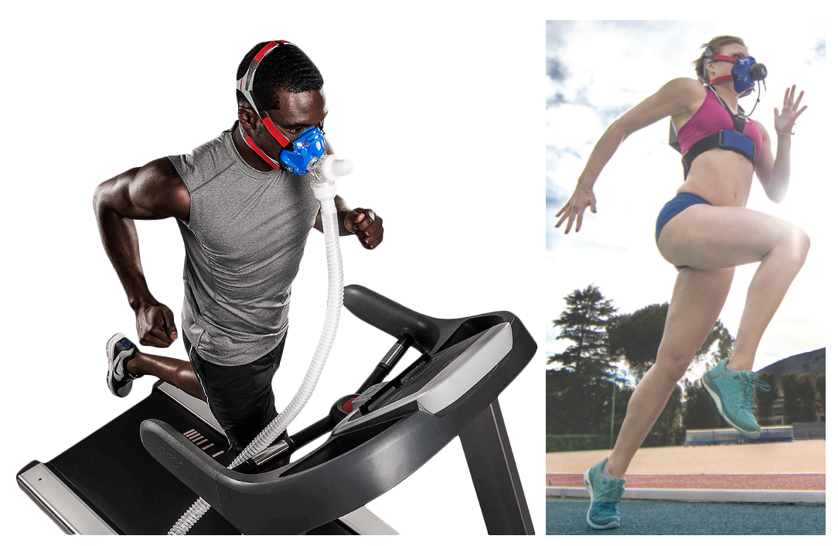
Figure 1: Masks used to measure oxygen consumption.
The heart ratio method where one measures heart rate during a period of exercise incrementally increasing in intensity (Equation 1). The heart rate ratio method was developed on well-trained males from 21 to 50 years old meaning applicability to other subgroups (age, gender, training status) could be less accurate.

${VO}_{2} ≈ \frac{{HR}_{max}}{{HR}_{min}} × 15.3 ml/ kg/ min$ (1)

Limitations of Current Measures
Traditional methods for measuring require measuring oxygen and carbon dioxide concentrations during inhalation and exhalation, whilst being subjected to physical activity (treadmill or ergometer). These methods require that participants complete physical activities under laboratory conditions, which require undesirable time and financial investments. Although, these methods are considered the gold standard for measuring VO₂, the difficulty of replicating similar condition in real world situations only adds to undesirability.

Research Direction
Given the impracticalities of traditional methods, new methods leveraging machine and deep learning have been proposed in recent years. One such method is using easily obtainable physiological metrics such as heart rate, weight and height in combination with deep learning models to predict difficult to obtain metrics (VO₂). Currently, several researchers have demonstrated promising results with simple model, thus potentially more advanced deep learning methods could yield even more accurate results. The following report will present findings showcasing the utility of advanced deep learning models in predicting oxygen consumption.

Methods

Data
Three sources of data we utilised during the following report as each source of data contained the necessary variables required. The first dataset was obtained from public data on Kaggle, which was linked to a pilot study that was completed. The researchers recruited seven recreational cyclists (6 males, 1 female) to complete three different protocols all measuring oxygen consumption (VO₂). Each of the protocols used an electromagnetically braked bicycle ergometer and began with a four-minute warm-up before completing each protocol. The first protocol consisted of completing a moderate-intense-light cycle three times. The second protocol included several phases where intensity gradually increased (ramping phases) to understand the full details of the second protocol see the figure below. The final protocol is more commonly known as the Wingate protocol, which consists of maximal intensity (i.e., All-out) for thirty seconds.

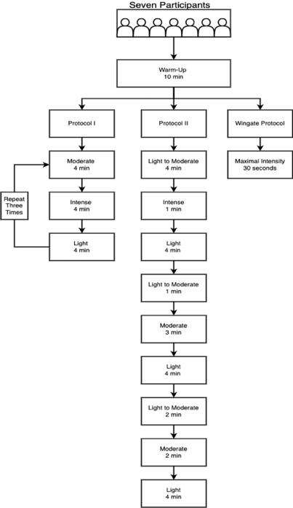
Figure 2: First datasets differing protocols.
The second dataset was obtained from the public data provided by the University of Malaga, which consisted of both amateur and professional athletes with ages ranging from 10 to 63 years old. All participants completed a single protocol, which required participants to perform a warm-up phase, a Wingate protocol, and a cooldown phase. There was a total of 980 participants.

The third dataset was obtained from the University of Uruguay. The dataset consists of six subjects performing three different exercises with several different protocols. Five subjects were males and one female. The running protocol required participants to complete the task a five differing speeds (7km/h, 8.5km/h, 10km/h, 11.5km/h and 13km/h). The skipping protocol required participants to complete the task also a differing speed (3km/h, 5km/h, 7km/h and 9km/h). The final protocol required participants to perform walking, which acted as a baseline for the previous two protocols.

Pre-processing

From the available dataset, only three of the six variables were selected as the remaining variables provided no increases in performance, unnecessary noise, and inflexibility.
After each variable underwent a min-max transformation to improve model accuracy and standardised data. The min-max transformation was completed on each individual’s relative minimum and relative maximum meaning that the maximum and minimum values, whilst the same between individuals represented different absolute maximums as aerobic capacities vary from individual to individual.

$$x^{'}= \frac{x-\min\left(x\right)}{\max\left(x\right)-\min\left(x\right)} (2)$$

Where $x=data for a given participant and given protocol$

Model

The implemented model can be divided into two sections, which are the long-short term neural network and the linear feedforward neural network.

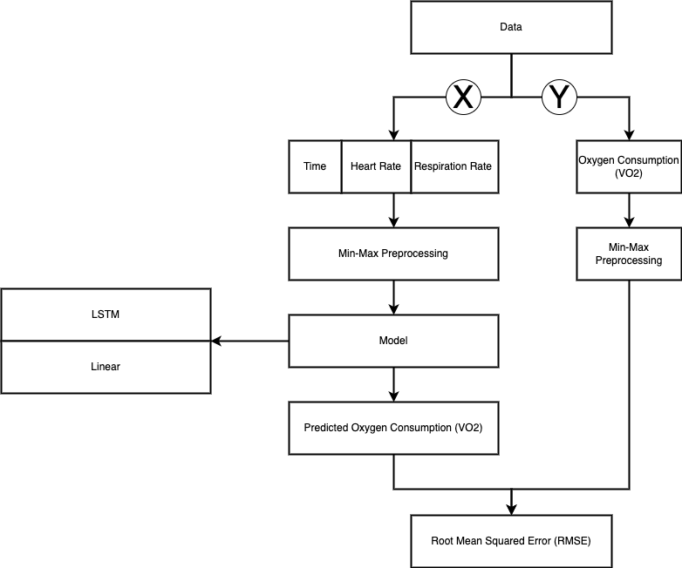
Figure 3: Workflow for model construction.

Results

The model predicted VO₂ throughout the duration of exercise with a reasonable amount oof success based on several metrics. The first metric being the coefficient of determination (R² = 0.895), which once optimised was able to achieve highly correlated values between real and predicted for VO₂. Secondly, mean squared error (MSE = 0.005) was extremely low with root mean squared error (RMSE = 0.074) and mean absolute error (MAE = 0.061) being considerably low also.

An example of the results obtained predicting oxygen consumption for a single individuals performing either skipping, cycling, or running are provided below.
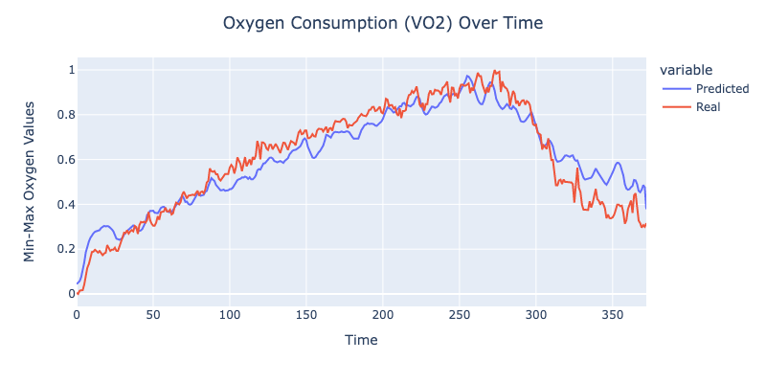

Conclusion

The following report outlines the successful implementation of a model capable of predicting oxygen consumption. Looking towards the future the following model ought to be tested in real-world condition, where an individual is performing exercise and oxygen consumption values are being predicted in real-time e.g., predicting oxygen consumption second-to-second during cycling. There are several limitations that, which require resolving. Firstly, the lack thereof real data specific to Redback Operations. The solution to the following issue is simple, yet difficult to resolve as one requires devices allowing for data collection through Redback operations. Secondly, define easily obtained inputs is difficult as Redback Operations are still undergoing early stages of development as such the inputs currently used may be deemed in the future difficult to obtain, thus one should keep in mind that the following inputs were easily obtained given the publicly available datasets. In sum, the following report outlines how one is able to use deep learning methods to predict oxygen consumption.

